Press Release Naomi W. Knight
FOR IMMEDIATE RELEASE Maryland FFA Program Coordinator
April 13, 2024 nknight@maefonline.com

MARYLAND FFA FOUNDATION ANNOUNCES RECIPIENTS OF THE GIFT OF BLUE
(HAVRE DE GRACE, MARYLAND) – April 13, 2024- The Maryland FFA Foundation is pleased to announce their annual recipients of the Gift of Blue Program. This program benefits those deserving and active FFA members in grades 9-11. Each chapter is eligible to request up to three FFA jackets at a cost of $20/jacket.
This year, 96 students representing 33 chapters received their own FFA jacket and matching tie/scarf in a presentation during a ceremony at the State Spring Judging Event on April 13, 2024 at Westminster High School. The event hosted over 460 members, advisors, parents and volunteers. The Maryland FFA Foundation has sponsored this generous event for the past nine years awarding 843 jackets to deserving members totaling over $42,250 through their foundation.
Region 1
Allegany: Leah Hite, Hailee Isom, Leigha Read
Boonsboro: Mackenzie Angle, Ava Leatherman, Esther Lowe
Boonsboro Middle: James Burke, Rebeka Davidson, Devin McCary
Boyd J. Michael III Tech: Autumn Beall, Brielle Long, Avery Long
Clear Spring: Kyleigh Jarrett, Dawson Miller, Sam Vowell
Smithsburg: Grace Bowers, Baylee Cook, Mary Dorment
Region 2
Brunswick: Joey Georg, Emma Pearrell, Lane Riggleman
Catoctin: Gabby Brauning, Faith May, Lizzie Schuebel
Frederick CTC: Tori Bell, Johanna Brashear, Cali Moregon
Linganore: Kyleigh Crum, Jenna Fountain, Emry Mayhew
Middletown: Irie Hammel, Brooke Haupt, Elijah Sowers
Oakdale: Lyla Ladd, Kylee Puryear, Megan Tu
Tuscarora: Kristina Dorsey, Julia Gates, Angel Mender
Urbana: Leah Ogg, Audrey Scholz, Addie Shavell
Walkersville: Chloe Carter, Gina Florimbio, Paige Riggs

Region 3
Calvert: Cameron Gagnon, Lillian Mooney, Nathan Nguyen
CAT-North: Colin McCallister, Riley Miller-Hubbard, Allyson Redmiles
Damascus: Mark Coleman, Logan Monarch, Alexander Stonesifer
Fairmont Heights: Kimberly Salazar, Ishtiaq Uthsho, Lanyah Worthington
Gwynn Park: Maya Gudderra, Pavan Raigor, Treasure Roberts
Howard County: Kaylee Brogan, Natalie Davis, Kate Wells
Maurice J. McDonough: Doriana Damo
Southern: Caroline Harding, Sasha Painter, CeCe Rock
Region 4
Century: Angeli Barragan, Hannah Marasco, Abhi Yadiapalli
Francis Scott Key: Andrew Putman, Josie Wilhide, Cole Zeigler
Liberty: Billy Herndon, Abigail Morsching
Manchester Valley: Joseph Battaglia, Jacob Brown, Andrew Koontz
North Harford: Clayton McGraw, William Rowan, Logan Sealy
South Carroll: Emmalea Bartolain, Trista Christiansen, Brennon Harrison
Westminster: John Duvall, Wyatt Findley, Kayleigh Hamilton
Winters Mill: Dillan Frushour, Carli Ireland, Sydney Schertz
Region 5
Queen Anne’s County: Beau Dulin, Trey Palmatary, Blake Quillen
Worcester Tech: Angelle Ayers, Aireonna Colman, Jordan Dyer
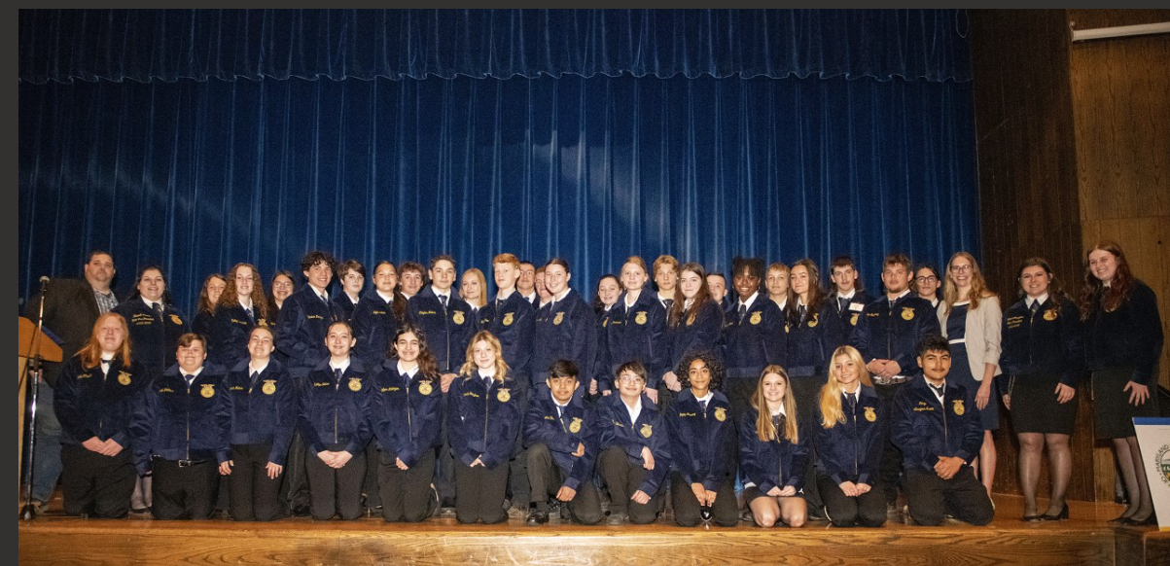
The Maryland Agricultural Education Foundation is a 501c3 non-governmental nonprofit established in 1989. Through the Maryland FFA, teacher workshops, scholarships, grants, Mobile Labs and Showcases, and revenues from the Ag Tag license plate sales, the Foundation pursues its mission to promote the understanding and appreciation of the importance of agriculture in everyone’s daily lives. The Maryland FFA Association’s staff team is partially funded through a $60,000 federal Perkins Grant facilitated by the Maryland State Department of Education. The Maryland FFA Association has 2,421 active members in 47 Chapters throughout the State.
For more information, visit www.mdffa.org or contact Naomi Knight at nknight@maefonline.com

